- Enable CloudTrail monitoring and store the events in S3 and CloudWatch log events.
Open Aws account and goto to cloud trail create trail give name then select new s3 bucket with a name then enable log validation for no alterations in log files then select cloud watch log give role as cloudtrail-events-role
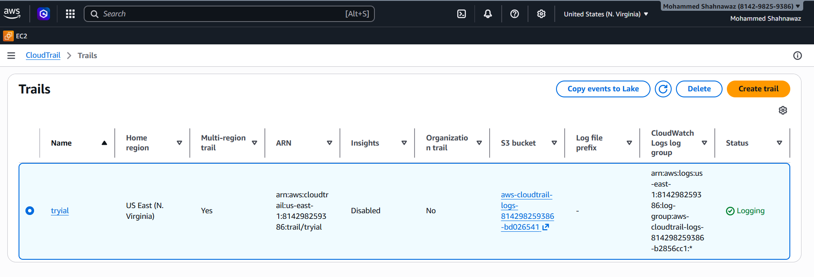
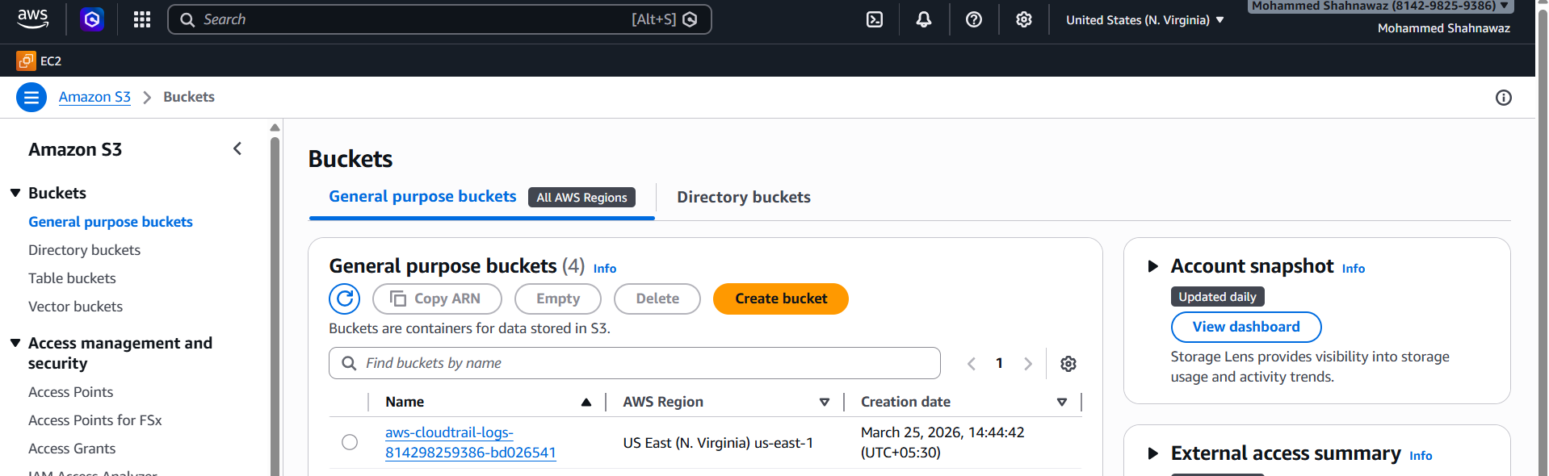
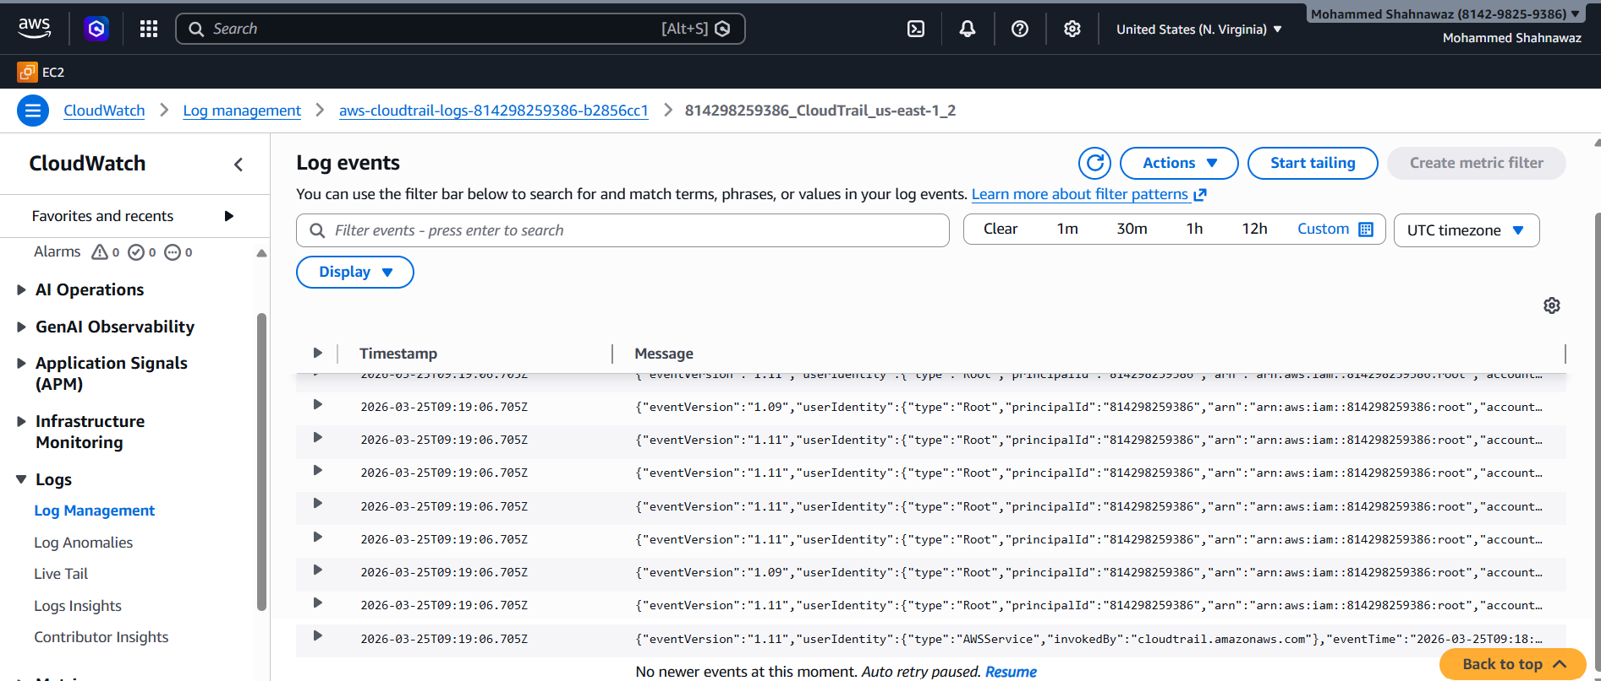
- Enable SNS for CloudTrail to send alerts via email.
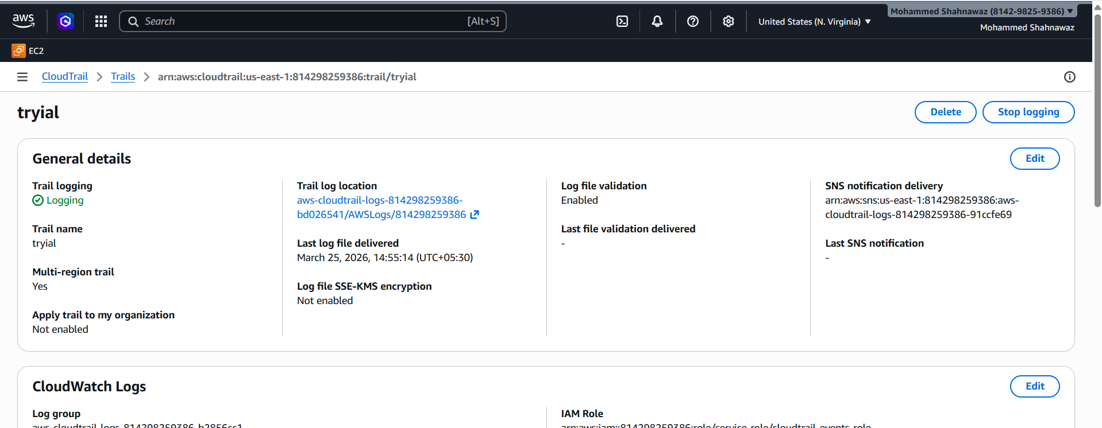
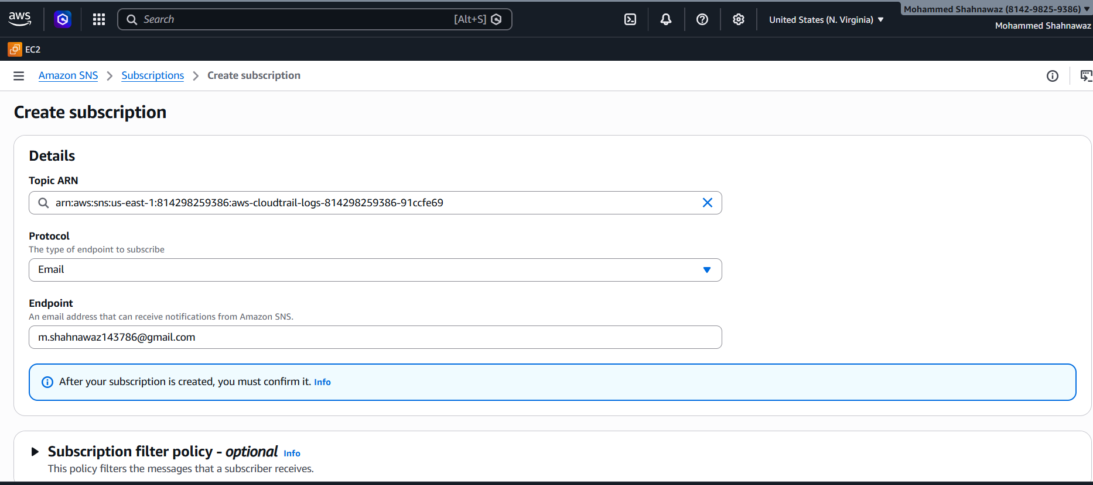
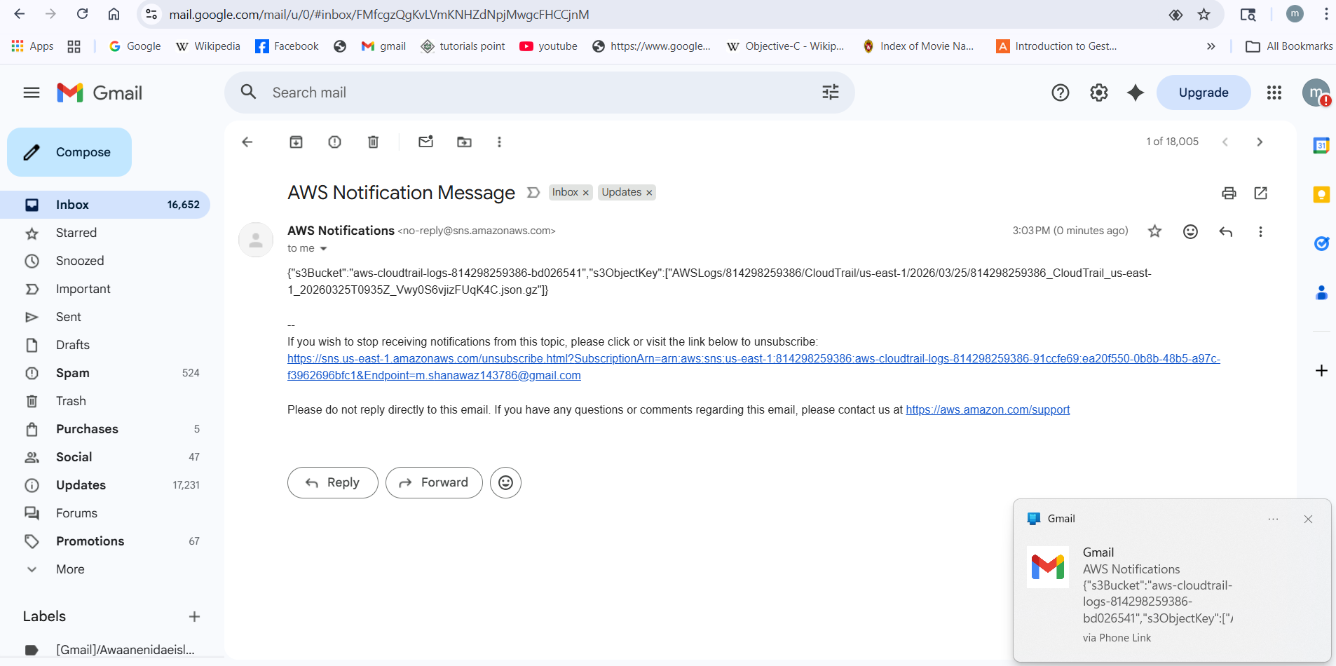
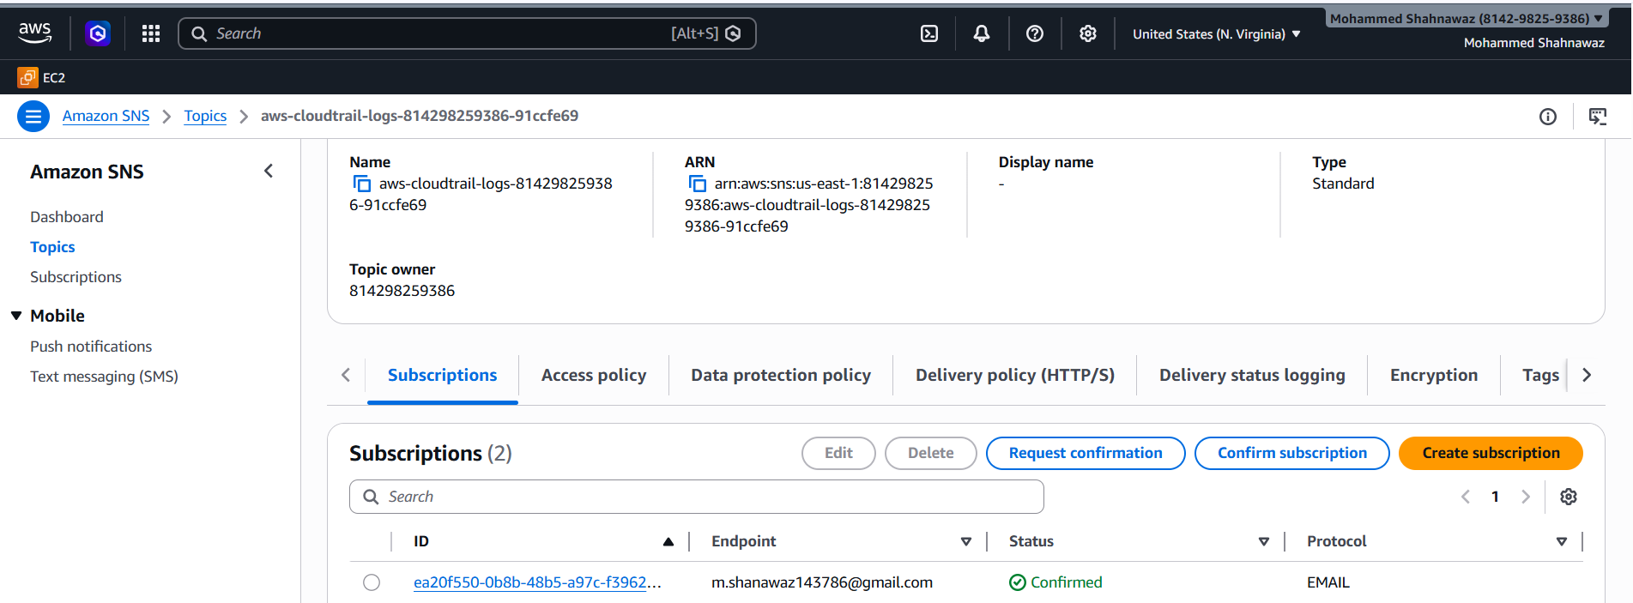
- Configure CloudWatch monitoring and record the CPU utilization and other metrics of EC2.
Goto cloudwatch click on dashboard create dashboard then give name add widget then
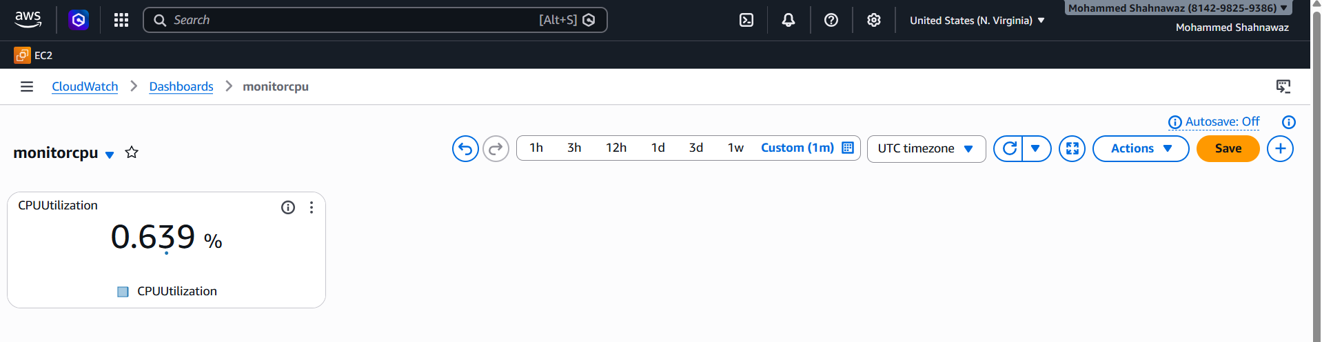
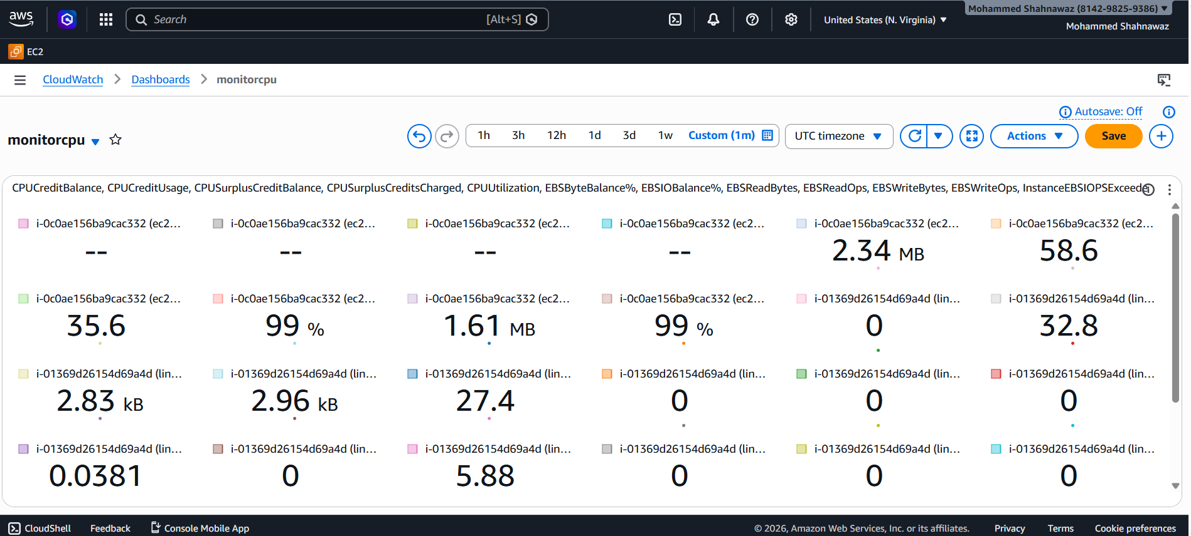
- Create one alarm to send an alert to email if the CPU utilization is more than 70 percent.
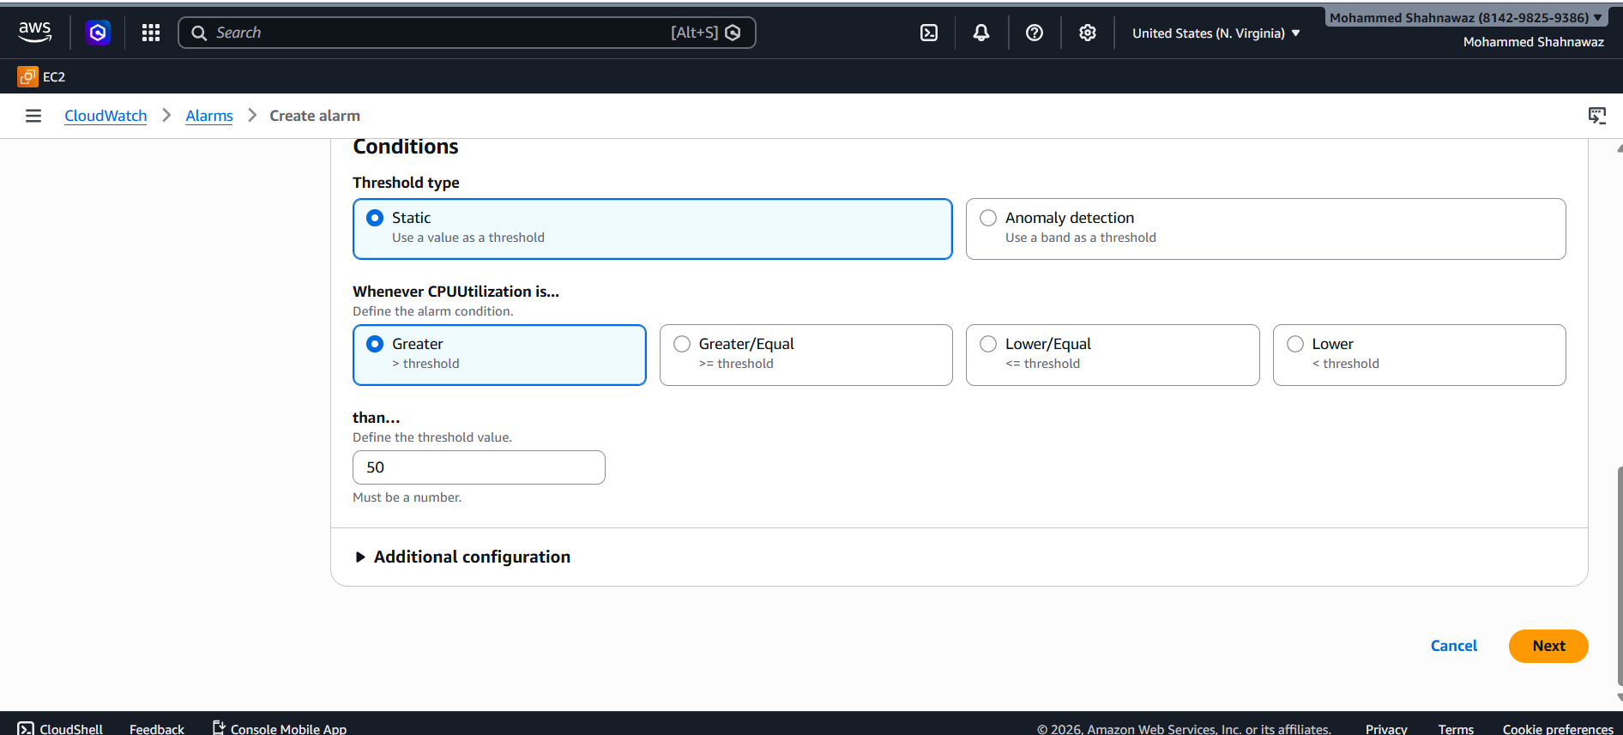
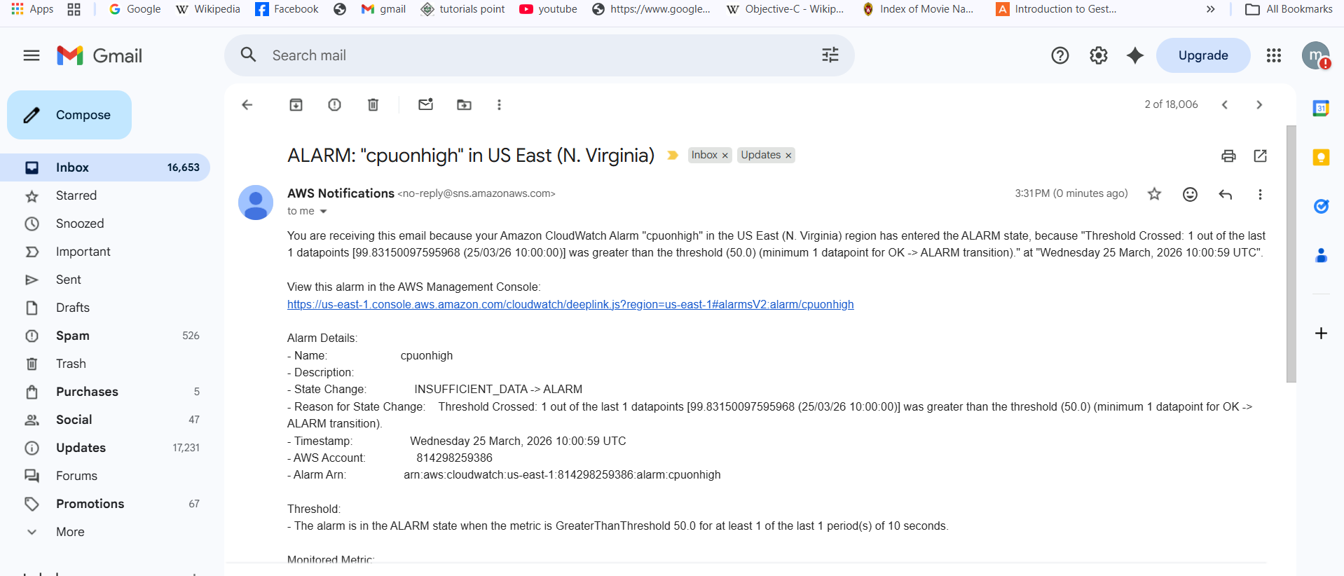
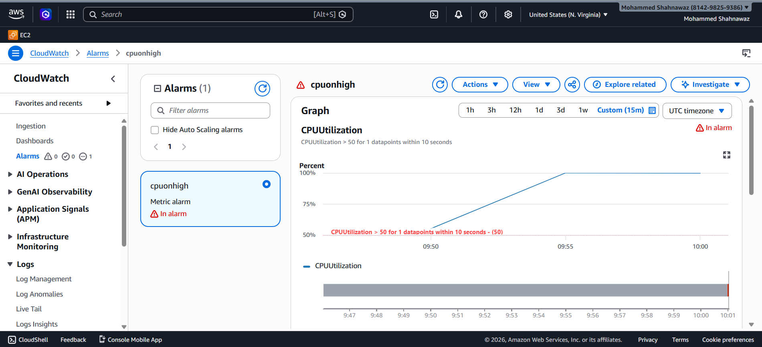
- Create a Dashboard and monitor the Tomcat service whether it is running or not and send the alert.
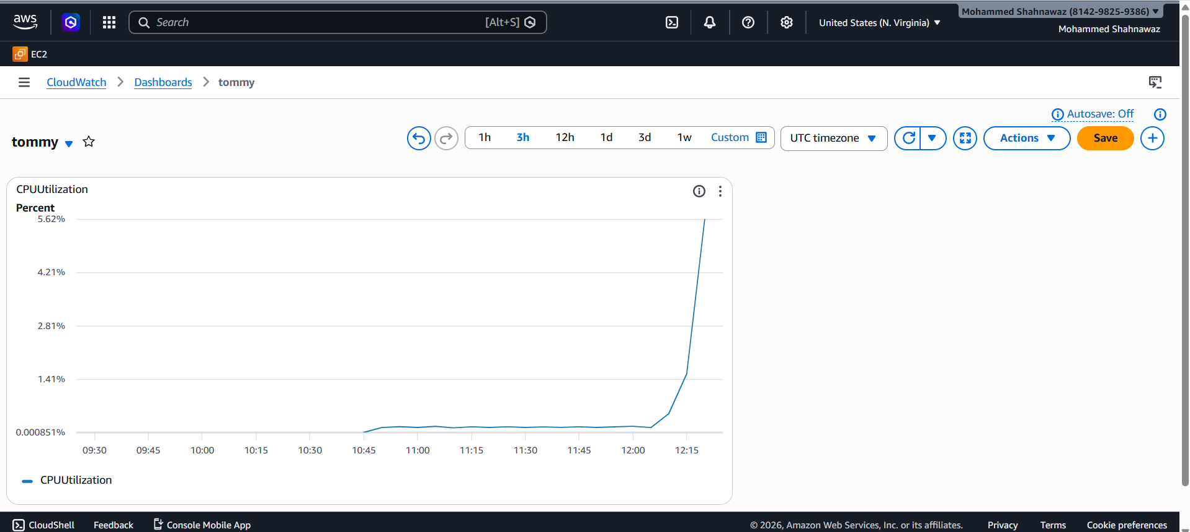
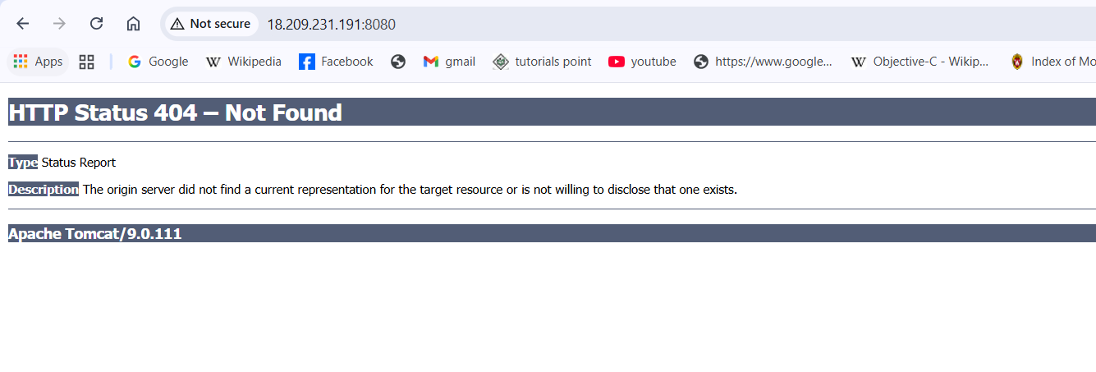
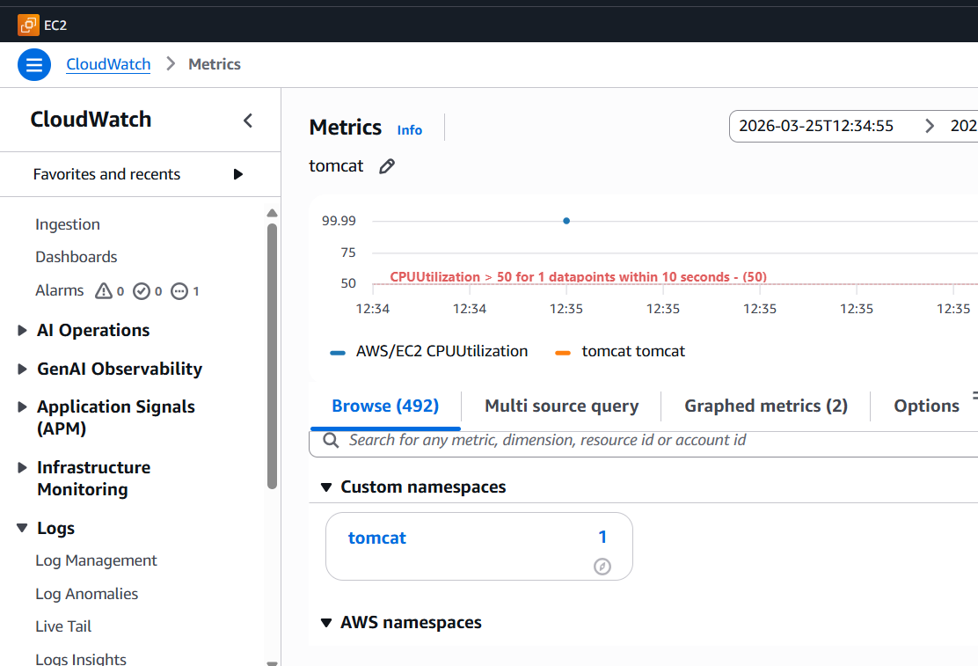
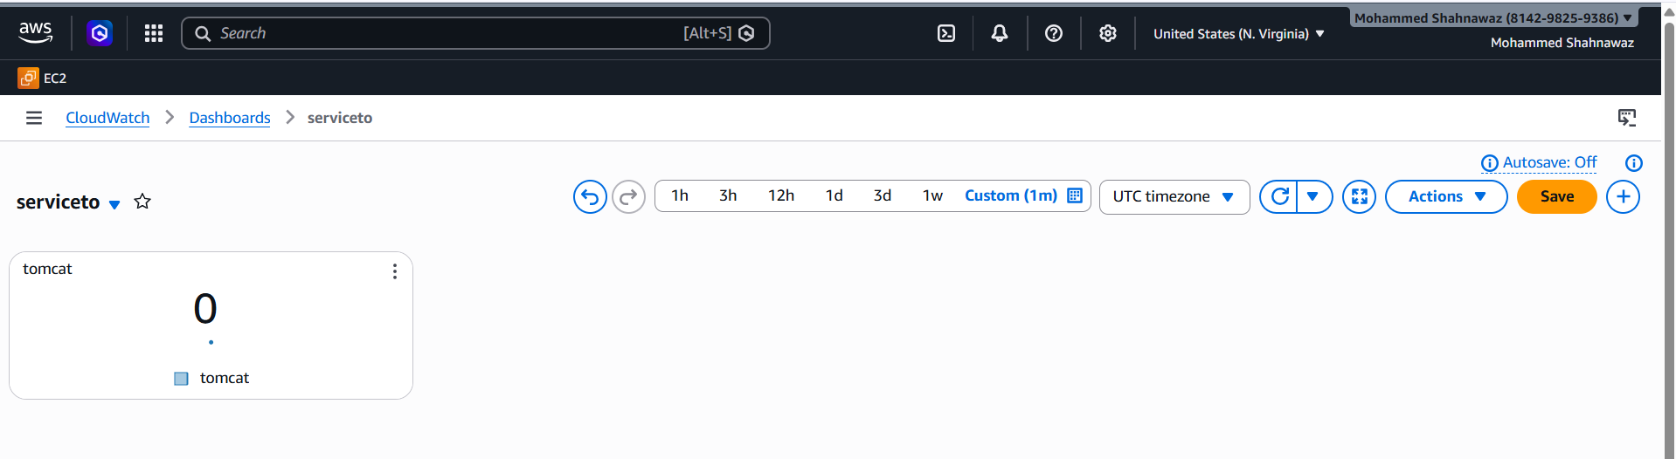

- Create a Dashboard and monitor the Nginx service to send the alert if Nginx is not running.
Open instance install nginx service then create a bash script for service then create a dashboard in cloud watch and add the metric then you will be able to monitor the service and get the notification if service is down.
